**Tutorial-1 answers:**

|  |  |
| --- | --- |
| 1 | i1=2.836A, i2=1.0758A, i3=1.54A |
| 2 | V=8V, R=3Ω |
| 3 | Power delivered by 60A source = 120W  Power absorbed by 15A source is 30W, 1/15 Ω resistor is 60W and 2/15 Ω resistor is 30W |
| 4 | Vx=8V, ix=1A |
| 5 | Current through 2 Ω resistor = 2.56A, voltage across 10 Ω resistor = 17.093V |
| 6 | (a) I=7A, and (b) VAB=5V and current through 5V source = 3.5 A |
| 7 | Current I1=0.33A (approx.) |
| 8 | Current through 4 Ω resistor = 1/27 A, Power delivered by 2 V source 0.89 W, Power delivered by 1 A source = 1.41 W |
| 9 | Power absorbed by 5V source = 6.25W and power delivered by 5A source = 192.5W |
| 10 | i1=1A, i2=2A, i3=3A and power associated with 10V source is 30W (absorbed) |
| 11 | Current through 1 Ω resistor is Ix=3.248A |
| 12 | Vth=13.9535V, and resistance R for maximum power transfer is R = Rth = 10.2325 Ω |

**Tutorial-2 AC Networks:**

1. 1. 1. Rms Value = k/√3
      2. Average = 0
      3. Form Factor = 2/√3
      4. Peak Factor = √3
   2. 1. Rms value = 0.475 Vm
      2. Average Value = 0.288 Vm.
2. 1. I2 = 2.64∠-26.6° A
   2. I3 = 1.67∠45° A
   3. V1 = 10.68∠6.33° V,
   4. V2 = 3.73∠18.4° V

Active and reactive power of parallel branches

Branch 2 = 6.96 W, 6.96 VAR

Branch 3 = 5.57 W, -2.8 VAR

Source = 37.6 W, 4.16 VAR

1. L = 15.9 mH,
   * 1. VAB = 147.9∠20.1° V,
     2. VBC = 79.49∠-39.77° V,
     3. I = 7.94∠-37.4° A
2. Q = 959.14 Var
3. C = 76 µF
4. I = 6.31A, P = 1262W

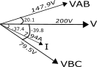

1. I = 1.5386∠-17.9°A
2. I = 2.26∠-9.03° A
3. P = 5801.8W pf = 0.835
4. R = 0.8Ω
5. 1. C = 382 µF,
   2. Is = 10∠36.87°A ,

IL = 10∠-36.87°A

Ic = 12∠90° A (taking Load voltage as the reference phasor)

**Tutorial 3 Transients**

1) 1A

2) 1 + 0.25e-10t A

3) 4.35 V

4) iL = 0 A, i1 = 0 A, i2 =10 A

5) 25+58.3e-0.8t V, 0.25+0.583e-0.8tA

6) 0.56+0.159e-6t A

7) 0.6+0.073e-3.57t A

8) 1.17 - 0.17e-12t A

9) 8e-4000000t A

10) (V/Z)sinθe-Rt/L + (V/Z)sin(ωt-θ)

where Z = √(R2+(ωL)2), θ=tan-1(ωL/R)

11) 0 V, 0 V/s, 1.67 V, 2.53 V/s, 1.67 V, 1.665 V/s, 5 V, 2.98 V

**Tutorial 4 Three Phase circuits**

1. IA =2 ∠-67.4° kA, IB =2 ∠172.6° kA, IC =2 ∠52.6° kA (assuming ABC phase sequence and VA as reference)

54 MW, 6 MW.

1. IA =10.4 ∠-66.87° A, IB =10.4 ∠173.13° A, IC =10.4 ∠-53.13° A
2. R = 16Ω, C=307.25 µF
3. 37.5 Ω
4. Iab =5.77 ∠30° A, Ibc =5.77 ∠-90° A, Ica =5.77 ∠150° A 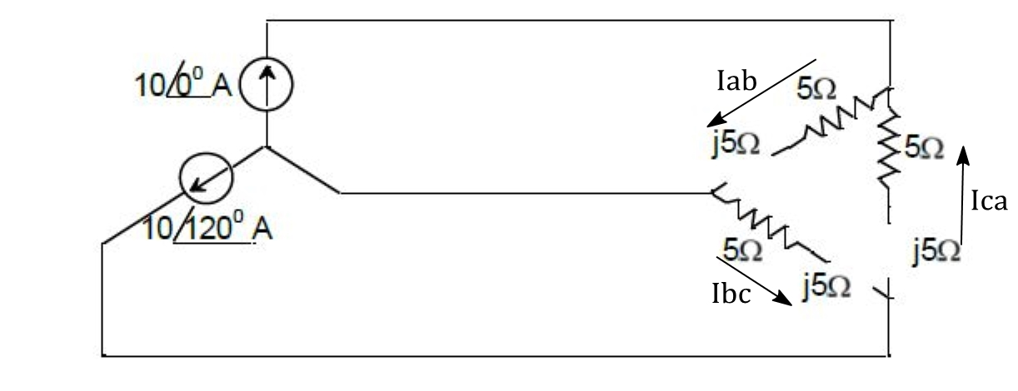
5. 41.53 A
6. IR1 = 23.09∠-30° A, IR2 = 23.09∠30° A
7. W1 = 1.35 kW, W2 = 3.62 kW
8. 7.2 kW